Explicit Teaching Checklist

Use this checklist as a planning document to help you design and deliver lessons using explicit instruction. You could also ask a colleague or an Instructional Design Specialist to review your lesson and fill out the form to obtain an outsider’s perspective.
Explicit Instruction Practices | Did I Include This? | Comments
Rationale (Why)
From the student perspective, clearly explain the objectives or competencies the learners will be able to do upon completion of the exercise. (QM 2.3) | Yes Somewhat No
Bridges the gap between students’ prior knowledge and new learning. | Yes Somewhat No
Assignment is aligned with Major Learning Outcomes (QM 2.1, 2.2, 3.1, 4.1, 5.1, 6.1) | Yes Somewhat No
Verbalize (What)
Give a clear, concise, and correct explanation of the skill. | Yes Somewhat No
Success criteria transparent (rubric, grading criteria) | Yes Somewhat No
Model (How)
Explain or demonstrate the skill in the same way students will practice it. Provide visual, auditory, kinesthetic (movement), and tactile means for illustrating metacognition, and important aspects of the concept/skill (e.g. visually display word problem and equation, orally cue students by varying vocal intonations, point, circle, highlight computation signs or important information in story problems). | Yes Somewhat No
"Think aloud" as you perform each step of the skill (i.e., demonstrate to students your thinking processes as you are walking through the assignment – metacognitive thinking). | Yes Somewhat No
Show multiple examples | Yes Somewhat No
Show all the steps | Yes Somewhat No
Practice
Provide opportunities for guided practice (QM 5.2) | Yes Somewhat No
Provide opportunities for independent practice (QM 5.2) | Yes Somewhat No
Check for understanding in multiple ways | Yes Somewhat No
Feedback
Observe student work | Yes Somewhat No
Deliver timely and specific feedback (QM 3.5) | Yes Somewhat No
Measure against success criteria (rubric, grading criteria) | Yes Somewhat No
Collect student data to make decisions about next steps for instruction | Yes Somewhat No
Revisit
Do a cumulative review of old and new skills | Yes Somewhat No
Revisit what was covered and ties it all together | Yes Somewhat No
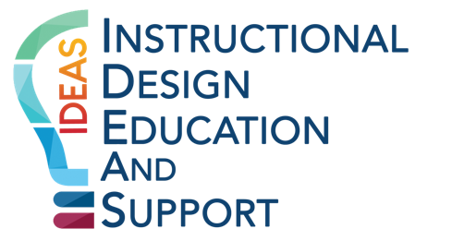

Adapted from: Explicit Instructions Checklist, Understood for All, Inc., 2019.

